Team Quaternary:

ST10019838 - Damian Dare

ST10019972 - Guillaume Swanevelder

ST10091991 - Christiaan Versfeld

ST10158660 - Ruan Zwarts

Module: XBCAD7319

Lecturer: Ms. Mmaphuti Matau

Documentation: Non-Functional Requirements Based on ISO/IEC 12207

# Table of Contents

Table of Contents 2

1. INTRODUCTION 3

2. Overview of ISO/IEC 12207 3

3. Key Non-Functional Requirements Aligned with ISO/IEC 12207 4

3.1 Performance 4

3.2 Scalability 4

3.3 Reliability 4

3.4 Maintainability 5

3.5 Security 5

3.6 Usability 6

3.7 Interoperability 6

3.8 Compliance with South African Regulations 7

4. CONCLUSION 7

5. REFERENCE LIST 8

# INTRODUCTION

Non-functional requirements (NFRs) specify a system's operation as opposed to the precise tasks it completes. These specifications are essential for guaranteeing the software's scalability, security, dependability, and quality. The ISO/IEC 12207 standard was chosen to direct the application's development and deployment. This international standard defines best practices for software engineering and offers a framework for software lifecycle activities. The project guarantees adherence to internationally acknowledged industry standards by following ISO/IEC 12207, which fosters robustness, uniformity, and maintainability.

# Overview of ISO/IEC 12207

The ISO/IEC 12207 standard outlines software lifecycle processes, including:

1. System and Software Requirements Definition: Ensuring clarity and completeness of all functional and non-functional requirements.
2. System and Software Design: Emphasising scalability, modularity, and security.
3. System and Software Implementation: Ensuring code quality, documentation, and compliance with security protocols.
4. System Integration and Testing: Conducting thorough testing to ensure reliability and performance.
5. Operation and Maintenance: Establishing processes for updating and maintaining the system post-deployment.

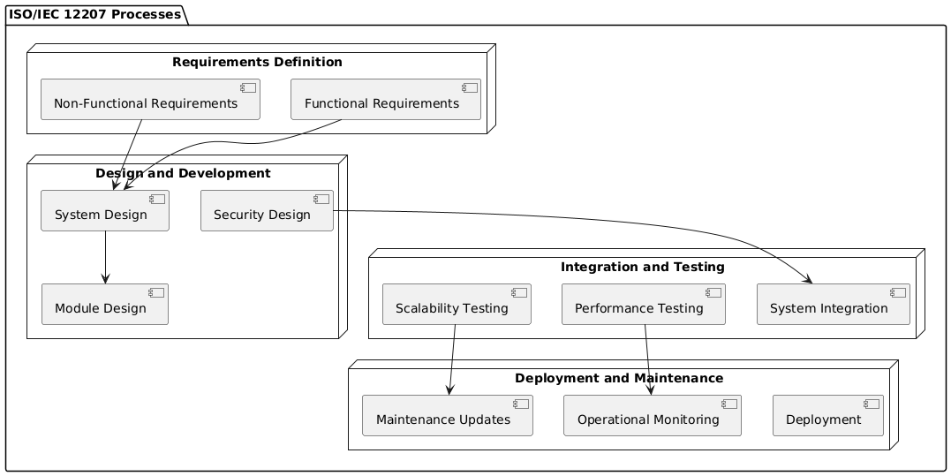

# Key Non-Functional Requirements Aligned with ISO/IEC 12207

## Performance

The system’s performance ensures quick response times and efficient handling of user requests. Key considerations include:

* Requirement:
  + All functionalities must respond within 7 seconds under load, supporting 5,000 concurrent users.
  + Capable of processing 100 concurrent transactions/second.
* Implementation:
  + Optimised server-side rendering in Next.js reduces latency.
  + Database indexing in Supabase ensures fast query execution.
  + Regular caching updates every 5 minutes to prevent stale data.
* Compliance with ISO/IEC 12207:
  + Emphasises performance metrics during system testing and deployment phases.

## Scalability

Scalability ensures the system can grow with increasing user demand and data volume.

* Requirement:
  + Support for a tenfold increase in transactions and storage over two years.
  + Dynamic resource allocation based on traffic.
* Implementation:
  + Cloud-based hosting on Vercel and Supabase supports automatic scaling.
  + Horizontal scaling allows for adding new nodes during high traffic.
* Compliance with ISO/IEC 12207:
  + Integrates scalability evaluations during design and operational readiness phases.

## Reliability

The system ensures continuous operation and data integrity, even during failures.

* Requirement:
  + 95% uptime and 1-hour recovery time (MTTR).
  + Redundant backups for critical components.
* Implementation:
  + Regular backups with Supabase and redundancy for essential data.
  + Implemented error-handling mechanisms and recovery processes.
* Compliance with ISO/IEC 12207:
  + Requires robust fault-tolerance measures during integration testing.

## Maintainability

Maintainability focuses on the ease of making updates and fixing issues in the system.

* Requirement:
  + Modular design for ease of updates.
  + Clear documentation of code, architecture, and user manuals.
* Implementation:
  + Code modularisation using Next.js for easier debugging and updates.
  + Comprehensive documentation for all components.
* Compliance with ISO/IEC 12207:
  + Enforces documentation and version control across all lifecycle stages.

## Security

Security protects sensitive data and ensures authorised access.

* Requirement:
  + Implemented Role-Based Access Control (RBAC).
  + Encrypted data at rest and in transit.
* Implementation:
  + Authentication and RBAC with Clerk.com.
  + Data encryption through Supabase’s built-in capabilities.
* Compliance with ISO/IEC 12207:
  + Mandates security protocols throughout development and testing.

## Usability

The system prioritises user-friendliness, accessibility, and intuitive design.

* Requirement:
  + A consistent, responsive interface compatible with all devices.
  + Accessibility for users with disabilities.
* Implementation:
  + Frontend developed in React for responsiveness.
  + Accessibility features like screen-reader support for inclusivity.
* Compliance with ISO/IEC 12207:
  + Requires usability testing during validation phases.

## Interoperability

Interoperability ensures seamless integration with other systems and platforms.

* Requirement:
  + APIs to facilitate backend and database communication.
  + Compatibility across all browsers and devices.
* Implementation:
  + RESTful APIs developed using Next.js for seamless frontend-backend communication.
  + Responsive design ensures compatibility with multiple devices.
* Compliance with ISO/IEC 12207:
  + Integration protocols are tested during system integration phases.

## Compliance with South African Regulations

Given the application’s deployment in South Africa, compliance with POPIA (Protection of Personal Information Act) is essential.

* Requirement:
  + User data protection and informed consent.
* Implementation:
  + Clear consent mechanisms implemented via Clerk.com.
  + Data encryption and limited data collection.
* Compliance with ISO/IEC 12207:
  + Aligns with requirements for regulatory adherence during the operation and maintenance phases.

# CONCLUSION

The project complies with international best practices by following ISO/IEC 12207, guaranteeing a scalable, secure, and reliable application. This standard improves the system's quality and maintainability by offering a thorough framework for handling non-functional requirements. The project not only meets but surpasses expectations thanks to careful planning, design, and testing, providing a solid basis for future expansion and sustainability.

# REFERENCE LIST

PlantText, 2024. *PlantUML.* [Online]   
Available at: https://www.planttext.com/  
[Accessed 24 10 2024].